**SPRINT 5 PLANNING**



**Author: Imagineers Team**

**Date: 26/04**

**Revision history**

|  |  |  |  |
| --- | --- | --- | --- |
| **Version** | **Date** | **Author** | **Notes** |
| 1.0 | 26/04/2017 | Thạch Nguyễn | Create Document |
|  |  |  |  |

Contents

I. INTRODUCTION 4

1. Purpose 4

2. Audience 4

II. SPRINT 5 GOALS 4

III. SPRINT 5 BACKLOG 4

IV. SPRINT 5 TASK 5

V. SPRINT 5 DEFINTION OF DONE 5

# INTRODUCTION

## Purpose

This document describes how sprint 5 is planning. The plan describes in simple, straight forward term the processes required to ensure that the sprint 5 stories re estimated and ensures the goals of sprint 5.

## Audience

This document is created for Scrum team .

# SPRINT 5 GOALS

* This is the first sprint execution so the priority of the product as customer wishes is to have the profile of the member. Because every swap activities will base on the profile
* The next goal is finishing the sprint 5 selected stories with full artifacts that is defined in the “definition of done”
* Finishing the sprint 5 on time. With all the stories that was chosen to put in sprint 5
  + Sign in Facebook
  + Write review
  + View review page
  + Auto matched ( recommended swap)
  + Exchange swap detail

# SPRINT 5 BACKLOG

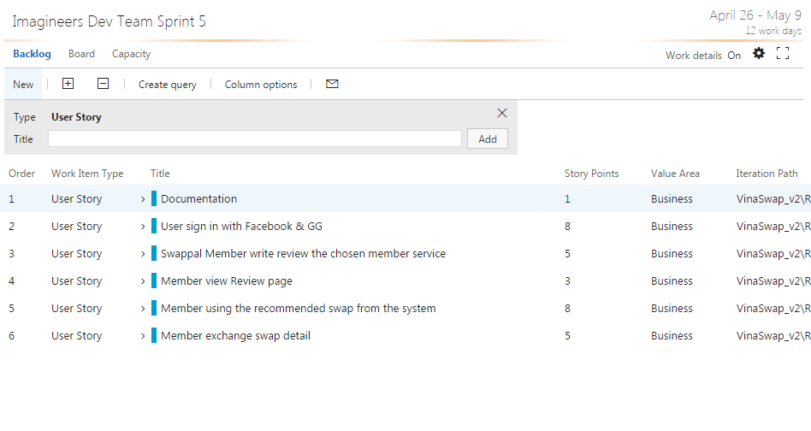

# SPRINT 5 TASK

|  |  |  |  |  |  |
| --- | --- | --- | --- | --- | --- |
| User story | Task | Assigned | Estimation (hrs) | Actual | Status |
| (hrs) |
| Documentation | Collect Sprint Artifact | Thach Nguyen | 5 |  |  |
|  | Write sprint report | Thach Nguyen | 8 |  |  |
| User sign in with Facebook | Code HTML/CSS | Quang Nguyen | 8 |  |  |
|  | Code client side | Quang Nguyen | 16 |  |  |
|  | Write functional test | Viet Dang | 3 |  |  |
|  | Write Use Case – Sign in Facebook | Phuong Nguyen | 5 |  |  |
|  | Write unit test – sign in facebook client side | Tai Nguyen | 8 |  |  |
|  | Run unit test – sign in facebook client side | Tai Nguyen | 4 |  |  |
|  | Build deploy | Thach Nguyen | 2 |  |  |
|  | Design UI | Phuong Nguyen | 4 |  |  |
|  | Write functional test | Viet Dang | 4 |  |  |
|  | Run functional test | Viet Dang | 4 |  |  |
|  |  |  |  |  |  |
| Swappal member write review | Design UI | Phuong Nguyen | 6 |  |  |
|  | Run functional test | Viet Dang | 8 |  |  |
|  | Code HTML/CSS | Quang Nguyen | 16 |  |  |
|  | Write Use Case – write review | Phuong Nguyen | 2 |  |  |
|  | Code client side – write review | Quang Nguyen | 16 |  |  |
|  | Code server side – write review | Chanh Tran | 12 |  |  |
|  | Write unit test – client side | Tai Nguyen | 8 |  |  |
|  | Run unit test – client side | Tai Nguyen | 8 |  |  |
|  | Write functional test case | Viet Dang | 2 |  |  |
|  | Run functional test | Viet Dang | 4 |  |  |
|  | Write unit test – server side | Tai Nguyen | 8 |  |  |
|  | Run unit test – server side | Tai Nguyen | 8 |  |  |
|  | Run unit test –server side | Tai Nguyen | 4 |  |  |
|  | Write Unit test –client side | Tai Nguyen | 8 |  |  |
|  | Run Unit test –client side | Tai Nguyen | 4 |  |  |
|  |  |  |  |  |  |
| Member view review | Code server side | Chanh Tran | 8 |  |  |
|  | Write unit test – client side | Tai Nguyen | 6 |  |  |
|  | Run unit test – client side | Tai Nguyen | 2 |  |  |
|  | Write unit test – server side | Tai Nguyen | 8 |  |  |
|  | Write unit test – serve side | Tai Nguyen | 8 |  |  |
|  | Write functional test case | Viet Dang | 2 |  |  |
|  | Run functional test | Viet Dang | 2 |  |  |
|  | Code client side | Quang Nguyen | 8 |  |  |
| Member using recommended swap | Write unit test | Tai Nguyen | 8 |  |  |
|  | Run unit test – client side | Tai Nguyen | 4 |  |  |
|  | Write User case – using auto matched | Phuong Nguyen | 5 |  |  |
|  | Build deploy product environment | Thach Nguyen | 4 |  |  |
|  | Code HTML/CSS | Quang Nguyen | 8 |  |  |
|  | Code server side | Chanh Tran | 16 |  |  |
|  | Code client side | Quang Nguyen | 16 |  |  |
|  | Write functional test | Viet Dang | 4 |  |  |
|  | Run functional test | Viet Dang | 2 |  |  |
| Member exchange swap detail | Design UI | Phuong Nguyen | 8 |  |  |
|  | Code HTML/CSS | Quang Nguyen | 8 |  |  |
|  | Code client side – exchange swap | Quang Nguyen | 20 |  |  |
|  | Code server side – exchange swap | Chanh Tran | 20 |  |  |
|  | Write unit test – exchange swap client side | Tai Nguyen | 8 |  |  |
|  | Run unit test – exchange swap client side | Tai Nguyen | 4 |  |  |
|  | Write unit test – exchange swap server side | Tai Nguyen | 8 |  |  |
|  | Run unit test – exchange swap server side | Tai Nguyen | 4 |  |  |
|  | Write use case - exchange swap | Phuong Nguyen | 4 |  |  |
|  | Run functional test – exchage swap | Viet Dang | 4 |  |  |
|  | Write functional test | Viet Dang | 4 |  |  |

# SPRINT 5 DEFINTION OF DONE

|  |  |
| --- | --- |
| Category | Detail |
| User Story Clarity | User stories selected for the sprint are complete with respect to product theme, understood by the team, and have been validated by the detailed acceptance criteria. |
| Tasks Identified | Tasks for selected user stories have been identified and estimated by the team. - |
| Product owner approval | Each finished user story has been passed through UAT (User Acceptance Testing) and signed off as meeting requirements |
| Updating Product Backlog | All features not done during the sprint are added back to the product backlog. All incidents/defects not handled during the sprint are added to the product backlog. |
| Environment ready | Development environment is ready with all third-party tools configured.  Staging environment is ready.  Continuous integration framework is in place  Test data for the selected features has been created |
| Design complete | Design analysis is complete as per the user story or theme.  Prototype have been created and approved by the respective stakeholders.  Use cases are developed |
| Unit test cases written | Unit test cases have been written for the features to be developed |
| Documentation Ready | Documentation to support the sprint demo is ready |
| Code Complete | Source code changes are done for all the features in the “to do” list.” Source code has been commented appropriately. |
| Unit testing is done | Unit test cases have been executed and are working successfully |
| Code Refactoring | Source code has been refactored to make it comprehensive, maintainable and, amenable to change. |
| Code checkin | Source code is checked in the code library with appropriate comments added. |
| Code merging and tagging | Finalized source code has been merged with the main branch and tagged appropriately (merging and tagging guidelines are to be used) |
| Project metrics are ready | Burndown chart has been updated regularly and is up to date. |
| Functional testing done | Test team has reviewed and conducted necessary manual test cases to ensure that tests are passing. All incidents/defects are reported.  100% executed test cases and 80% test cases pass.  There are no major defect occurred  Accept 20% minor defects in layout or the defect doesn’t affect system |
| Acceptance testing done | Each finished user story has been passed through UAT (User Acceptance Testing) and signed off as meeting requirements (see also Product Owner Approval). |
| Closure | All finished user stories/tasks are marked complete/resolved. Remaining hours for task set to zero before closing the task. |